Meiosis Video

http://www.watchknowlearn.org/Video.aspx?VideoID=56202&CategoryID=7580

1. How many chromosomes do your body cells have? ____________________ 46 _____________________
(1 mark)

2. Which cells don’t have 46 chromosomes? ________________ sperm and egg ____________

_____________________________________________________________________________________________________________
(1 mark)

3. How many chromosomes do they have? ________________________________ 23 _________________________

_____________________________________________________________________________________________________________
(1 mark)

4. Why do they have this many? ______ so when they join they only have 46 ________

_____________________________________________________________________________________________________________
(1 mark)

5. What is the other name for egg and sperm cells? _____________ gametes ______________

_____________________________________________________________________________________________________________
(1 mark)

6. Why is meiosis called reduction division? _____________ because you start with 46 and end

with 23 chromosomes _________________________________________________________________________________
(1 mark)

7. In meiosis how do the new cells compare to the original? ____ they are different ________

_____________________________________________________________________________________________________________
(1 mark)

8. “Mitosis makes us _______ identical _________”
(1 mark)

9. “Meiosis makes cells that are ________ different _______ from one another”
(1 mark)

10. What are cells doing in interphase? _____ growing, replicating DNA, carrying out cell

processes ______________________________________________________________________________________________
(1 mark)

11. How many times does PMAT happen in meiosis? ____________ twice _____________________
(1 mark)

12. What does homologous mean? ______ same size, same type, same location _______

_____________________________________________________________________________________________________________
(1 mark)

13. Describe crossing over ______ transfer genetic material from one chromosome to another

_____________________________________________________________________________________________________________
(1 mark)

14. What has happened by telophase I? ______ two cells ___________

_____________________________________________________________________________________________________________
(1 mark)

15. How many cells are there by telophase II? _______________________ four cells ____________

_____________________________________________________________________________________________________________
(1 mark)

16. How many chromosomes in an sperm cell? _______________________________ 23 __________________

_____________________________________________________________________________________________________________
(1 mark)

17. What can cause genetic disorders? ___ too many or too few chromosomes, don’t separate

correctly _____________________________________________________________________________________________
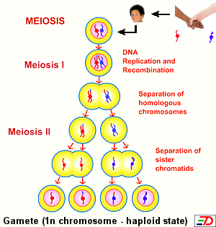
(1 mark)

